Curriculum Vitae

Stephen James Bray

DENTAL EXPERT WITNESS

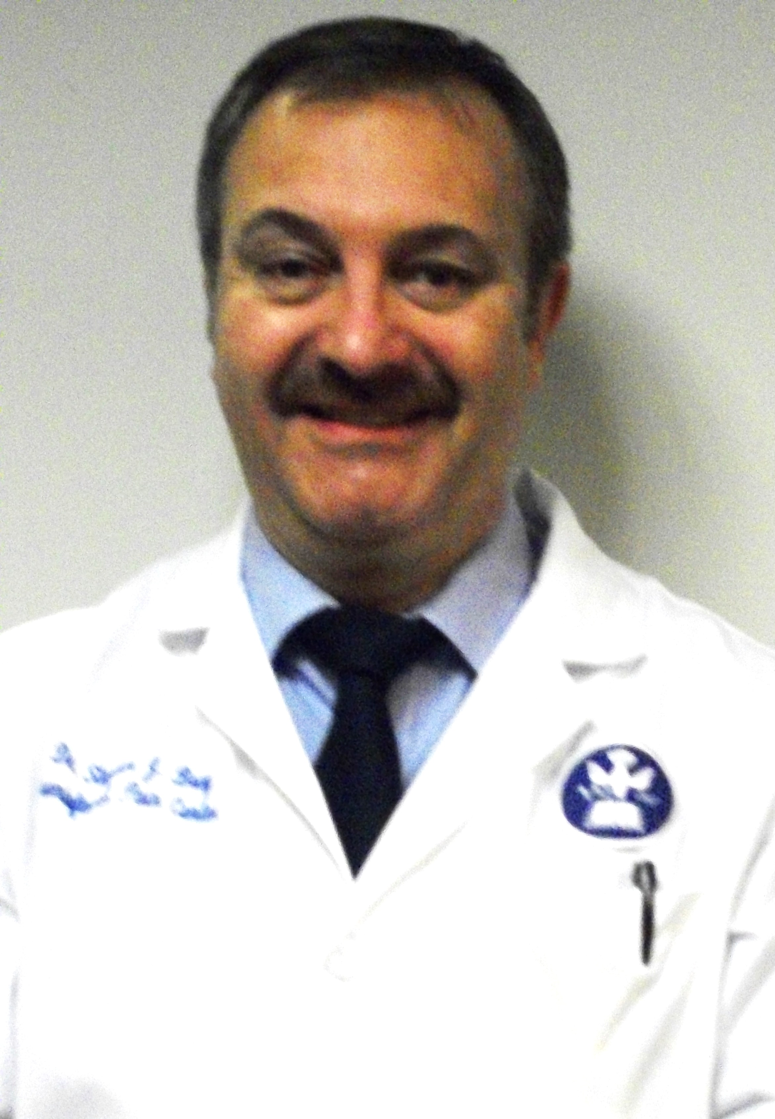

PERSONAL INFORMATION

Office. (T) - 250 575 0717
(F) - 250 869 0071

Administration Office: Unit 2 – 1335, Dilworth Crescent,
Kelowna, BC,
V1Y 4M6

Date of Birth: 19/02/1956
Place of Birth: Hornchurch, Essex, England
Nationalities: British / Canadian
Languages spoken: English

e-mail: drsbray@yahoo.ca

Website: www.dentalexpertwitness.ca

Qualifications

2011 P.G.Dipl. (BSM) University of Glasgow.
2010 F.O.P. (Tufts) Fellowship in Orofacial pain and sleep disorder, Tufts University. Boston.
2005 P.G. Cert (Pros) Kings College London
2003 M.F.D.S. (Ed) Membership exam Royal College of Dental Surgeons of Edinburgh
2003 M.F.D.P.S.G. Membership exam Royal College Physicians and Surgeons of Glasgow
2002 F.I.C.C.M.O. Fellowship: International College Craniomandibular Orthopedics
1981 D.D.S University of Toronto, Toronto, Ontario
1978 B.D.S. (Hons) London Hospital Medical, Dental College, London, Distinction in Medicine
1974 Cooper’s Company’s Grammar School, London, England

Postdoctoral Training:

2015 Expert Witness Forensic Report Preparation and Courtroom Skills. (UK)
2013 Achieved re-instatement for BC licence (CDSBC)
2011 Achieved examination for (present) full Massachusetts dental license
2010 Western Regional Dental Boards Examination; (W.R.E.B.)
2010 North Eastern Regional Boards Examination (N.E.R.B.)
2009 Massachusetts Ethics and Jurisprudence Examination
2006 One-year Certificate level equivalence (Implantology) Royal College of
Dental Surgeons (England)
2005 International Congress of Oral Implantologists; University of Alabama.
2001 Membership exam for Faculty of General Dental Surgeons; Part I
1981 National Dental Examining Boards of Canada (N.D.E.B.)
1980 American Boards Exams Part I & II

(2)
Licensure and Certification to practice;

USA. Massachusetts. Dental licensing Board of Registration, [Full]
Canada; British Columbia [Full]

Internships/Residencies hospital experience:
See Appendix A

Practice Positions:
See Appendix B

Faculty / Academic Appointments:
See Appendix C

Hospital Appointments:
See Appendix D

Other Professional appointments/presentations:
See Appendix E

Optional Continuing Education Courses taken,
See Appendix F

Membership:
AACP. American Academy of Craniofacial Pain (Canada)
AASM American Academy of Sleep Medicine (USA)
AADSM American Academy of Dental Sleep Medicine (USA)
SBSM Society of Behavioural Sleep Medicine (USA)
BSS British Sleep Society (UK)
BLF British Lung Foundation (UK)
BCDA British Columbia Dental Association (Canada)
Publications include;

2015 Article for legal publication submitted (TMJD and the personal injury claim)
2015 - monthly Physician’s Sleep Bulletin (Okanagan Valley Physicians).
2011 “An interview” given describing sleep disorders; BSS Newsletter
2011 “What is health?” Cranioview Journal submission;
2011 “Bite Disorders Parts I & II” Clinical Dentistry, JIDA
2010 “Obstructive Sleep Apnea, the basics” British Sleep Society Newsletter
2010 “An overview of neuromuscular dentistry” Clinical Dentistry, JIDA
2010 “Specialised dental tissues”. Clinical Dentistry, JIDA
2010 “Neuromuscular dentistry; a case report; Clinical Dentistry. JIDA
2006 “Antioxidants; follow-up on antioxidant research”; Editorial
2006 “The science and practice of Sleep medicine” Cranioview J. Editorial
2006 “Treatment for TMD in general practice” Private Dentistry
2006 Review article; “The Role of Neuromuscular Concepts in the treatment of TMD and Chronic Facial Pain. Glassman. B”
2006 “Obstructive Sleep Apnea”, a public disease.
2005 Review article; “Imaging of the TMJ”. Lotzoff. K. Independent Dentistry
Primary Care (Scottish Medical Journal)
2004 “The growing role of antioxidants in the prevention and co-therapy of clinical periodontal disease” Independent dentistry
2004 “Periodontal disease, diagnosis and treatment” Parts I, II & III
Independent Dentistry.
2004 “The science and practice of Sleep medicine” Cranioview; Editorial
2004 “The role of Neuromuscular concepts in the treatment of TMD and
Chronic facial pain” Cranioview Journal
2003 “The other foot and mouth disease” co authored A. Jackson (Podiatry)
2003 “An Indian Adventure”, an overview of the curriculum and philosophy
of SDM Dental College at Sattur, Dhward, India. Independent Dentistry
2002 Authored chapter in Clinical textbook (Spain) 2002, “Bases diagnosticas, terapeuticas y posturales del funcionalismo craniofacial” Tomo II.
(Bite registration techniques and positions).
2002 “The strange case of the clicking jaw”
Royal College of Dental Surgeons (Eng.) Journal “First Hand”

(3)

2002 “Replacement of amalgam fillings; advantages and disadvantages”.
Independent Dentistry
2002 “Bite registration” Parts I, II & III. Independent Dentistry.
2002 “Neuromuscular Dentistry” Independent Dentistry
2002 “An overview of neuromuscular dentistry” The Probe
2002 “Review of imaging techniques for the TM joint” Cranioview journal
2001 “Starting over”. Article; Independent Dentistry Journal.
2001 “An A-Z of Modern Dentistry”
Daily Mail (British Newspaper) Centre pages (Circulation 2.0 Million)
2001 “Unravelling the Mystery”, (Neuromuscular Occlusion) in private print.
2000 Presented ‘Service Appreciation Award’ College of Dental Surgeons of British Columbia (1984-2000)
1977 “Loss of a Root Face Restoration” a case study and conjunction with
Mr. David Schwarz. British Dental Journal. 1977

Expert Witness Services

1. Desktop reports.
Short independent report and opinion prepared to assist in decision of, ‘an adequate foundation for advancement of case’.

2. Expert Witness Reports. Preparation of Expert Witness Forensic Reports (Personal Injury);
Involving damage to the teeth and/or surrounding areas, with a special interest in jaw joint injury or airway issues. (Reporting for plaintiff or defense’s counsel).

3. Expert Witness Reports following allegations of clinical negligence in dental practice.
(Reporting for claimant allegation or defense counsel).

4. Alternative Dispute Resolution (ADR) services.

5. Courtroom Appearance (Dental Expert Witness.)

..............................................................................................................

Appendices

Appendix A
Internships/Residencies hospital experience:

2012 Honorary Clinical Observership (Clinic and treatment planning) under Professor Anita Simonds. Royal Brompton Hospital.
2012 Honorary Clinical Observership. Mr.Bhik Kotecha consultant ENT and Past President Royal College of Medicine (Sleep Apnea Section)
2011 Neuroscience Laboratories and Sleep Centre University of Glasgow,
Prof. C.Espie
2011 Weekly, Grand Rounds at Children’s Hospital (Harvard) Boston; Dr. S.Kothare.
2011 Weekly PSG Sleep studies; Children’s Hospital (Harvard) Boston; Dr. E. Katz
1987-97 Consulting and Clinical Practice (KGH. B.C) High medical risk, AIDs, special needs and surgical patients. (G.A.)
Operating Room privileges (Dr Baxter anaesthetist) KGH
1978-9 Resident, Department of prosthetics, London Hospital (LHMC)
1978 General Residency London Hospital Medical College Dental School (LHMC)

Appendix B
Practice Positions:

2015 Legal Expert Witness and associated services.
Independent Dental Advice.
Obstructive Sleep Apnea, Snoring and associated Sleep Disorder Management.
Headache, Oro-facial pain and Jaw Joint Disorder management.
General Dental Practice (volunteer).
2013-4 Sleep Disorders Clinic, Kelowna, BC
2007-9 General practice, emphasis on facial pain & sleep disorders
2007 UK pain practice, sleep disorders, myofascial and tension headache
2004 West Central London Harley Street practice (TMJD & full mouth reconstruction)

(4)

2003 Practice limited to myofascial and tension type disorders (Using primarily computer-aided oral orthopaedic appliance construction)
2002-3 Continuing education, practice consultancy, writing.
1998-2001 Kelowna Partnership (3) B.C. Canada.
1984-8 Solo Practice, Kelowna, British Columbia Canada. Practice Owner.
1981-1984 Practice Northern Ontario Canada. (Associateship; two practices)

Appendix C
Faculty / Academic Appointments:

2006/15 Legal
Expert witness Services, Kelowna, B.C. Canada
Expert witness Services, Cambridge County Court, England
2010-13 Clinical instructor,
Gelb Craniofacial Pain, Headache and Sleep Center,
Tufts University, School of Dental Medicine, Boston Massachusetts. USA.
2009 Advisory/consultancy.
Obstructive Sleep Apnea; advisor, ‘Gentle Dental’ Practices (28 practices) USA.
2009 Corporate presentation advisory - Life Healthcare Communications Ltd. (U.K.)

Appendix D
Hospital Appointments:

1988-1997 Kelowna General Hospital Consulting and Clinical Practice High medical risk, AIDs, special needs and surgical patients. (incl. O.R.)
1981-84 Consulting Dentist (Lady Dunn Hospital, Wawa, Ontario, Canada) High medical risk, AIDs, special needs and surgical patients. . (G.A.)
1981 Set up community practice (underserviced area; White River, Ontario, Canada) for Ontario government outreach program.
1979/80 Junior registrar, LHMC Dental School.

Appendix E
Other Professional appointments/presentations:

2015 British Columbia Dental Association representative for Legislative Member Assembly
2015 Vocational p/t practice; Kelowna Gospel Mission. 2014 C
2015 Commenced website; www.dentalexpertwitness.ca
CME Physician presentation – Snoring and Stroke
2014 Commenced educational website; www.snoringandsleepapneaclinics.ca
2014 Grand Rounds - Kelowna General Hospital, Kelowna. B.C.
2013 BSS Presentation to physicians, Bristol UK: Oral Appliance Therapy for OSA
2011 Presentation to ‘Gentle Dental’ Group (28 practices)
2011 Presentation to U.S. Pain Society Group
2006 Commenced educational website (2006); www.jawcentre.co.uk (presently inactive)
2005 Presentation on dental occlusion and TMJD - Post Graduate Group; Q Clinic, Harley Street, London. U.K.
2002 Assistant editor Journal ‘Cranioview’
-2000 Trainer for private practice associates (Kelowna BC)
1999 Toronto, Canada. Practice Administration Courses
1981 Achieved ‘American Endodontist’s Award”.
1981 University of Toronto. Orofacial Pain Program elective, published in University of Toronto Bulletin.
1980 University of Toronto Prosthodontics Program (Prof. George Zarb.)
1981 University of Toronto Orofacial Pain Elective Program.

Appendix F
Optional Continuing Education Courses,
(1998 onward) examples include:

2015 Expert Witness Report Writing. Expert Witness Institute. (London, UK)
2015 Practical Courtroom Skills; Paul Garlick Q.C. – (London, UK)
2015 American Academy Craniofacial Pain - 2015 Convention. (Vancouver, B.C.)
2014 - onwards Grand Rounds. Regular attendance Kelowna General Hospital, Kelowna, BC.
2013 Advanced Training in Oral Appliance Therapy. (Vancouver)

(5)

2013 Respiratory Technology. Thompson Rivers University, (Kamloops, BC)
2013 British Sleep Society Annual convention. (Bristol. UK.)
2013 AASM, Annual Sleep Symposium (Baltimore, USA)
2013 AADSM, Annual Sleep Symposium (Baltimore, USA)
2013 ABSM. Annual Sleep Symposium (Baltimore, USA)
2012 U. of Glasgow – Conference meeting (Behavioural Sleep Medicine)
(Weekly 2010-2012)
2012 AASM, Annual Sleep Symposium. (Boston, USA)
2012 AADSM, Annual Sleep Symposium. (Boston, USA)
2012 ABSM. Annual Sleep Symposium. (Boston, USA)
2012 BSS Annual Convention. (Bristol, UK.)
2011/12 Sleep Residency Program - Tufts School of Dental Medicine, (Boston, USA)
Dental Sleep Medicine Mini-Residency (All on-site curriculum modules)
2009-12 M.G.H./Harvard/Tufts Grand Rounds. (Weekly – 3 years) - (Boston, USA)
2010-11 Tufts Sleep Clinic Monthly Attendance, (Boston, USA)
2008 Association of Dental Implantology Course. (Dorset, UK) 1 - year course.
2006 Las Vegas Institute for Advanced Dental Studies (Baylor University, USA)
Implant Courses Part I and II
2004 Las Vegas Institute for Advanced Dental Studies (Baylor University, USA)
Advanced Aspects of Occlusion IV
2005 Elective study at SDM College and Dental Hospital, (Dhwad, India.)
2005 LVIADS (Baylor University) TMD Diagnosis and treatment planning.
2005 Childhood Facial and Dental Deformities, Airway and malocclusion. Dr. Garry.
2005 TMD Developmental Diagnosis (Dr James Garry DDS)
2005 Advanced Aspects of Occlusion Part III LVIADS (Baylor University USA)
2004 Advanced Scan Interpretation LVIADS (Baylor University USA)
2003 Orthognathic Occlusion – Dr. James Carlsson (London, UK)
2003 Advanced Aspects of Occlusion II; (Baylor University USA)
2002 Advanced Aspects of Occlusion; (Baylor University USA)
2001 TMD Management and Intervention LVIADS (Baylor University USA)
2001 Commenced and completed Full Mouth Reconstruction Training and examination. LVIADS (Baylor University USA)
2001 Team training in Biomedical Instrumentation LVIADS (Baylor University USA)
2000 Master anterior aesthetics LVIADS (Baylor University USA)
2000 Comprehensive Aesthetics LVIADS (Baylor University USA)
1999 Posterior Dental Aesthetics & Bonding Techniques LVIADS (Baylor University USA)
1999 Insomnia & Chronic Fatigue Syndrome (Vancouver, BC)
1998 Practice management (Toronto, Ontario)
1998 General Practice Orthodontic Courses Parts II, III, TMJD and Therapy. (London, UK)
1998 Sleep, Diet and the Brain. (Vancouver, BC)

